Overall Data Structure:

 | No activity data |  |  |  |  | Has activity data
 | Pin Point | Current (V2.611 and higher)
No |  | No mortality when collar is transmitting Argos message. |  | Has mortality when collar is transmitting Argos message. |  | No mortality when collar is transmitting Argos message. |  | Has mortality when collar is transmitting Argos message
1 | 0x11 (Header) | 0x10 (Header) |  | 0x12 (Header) |  | 0x14 (Header) |  | 0x16 (Header)
1 | 0x11 (Header) | Fix | Mortality Time | Fix | Mortality Time
2 | 2D/3D bit + Time | 2D/3D bit + Time | 0xFF  0xFF  0xFF | 2D/3D bit + Time | 0xFF  0xFF  0xFF | 2D/3D bit + Time |  | 2D/3D bit + Time
3
4
5 | Longitude | Longitude | Mortality Time | Longitude | Mortality Time | Longitude |  | Longitude
6
7
8 | Latitude | Latitude | 0xFF  0xFF  0xFF | Latitude | 0xFF  0xFF  0xFF | Latitude |  | Latitude
9
10
11 | CRC(2 ~ 10) | CRC(1 ~ 10) |  | CRC(1 ~ 10) |  | BIT0 = Mortality Flag  BIT1 = ACT1 valid flag  BIT2 = ACT2 valid flag  BIT3 = ACT3 valid flag  BIT4 = ACT4 valid flag |  | BIT0 = Mortality Flag  BIT1 = ACT1 valid flag  BIT2 = ACT2 valid flag  BIT3 = ACT3 valid flag  BIT4 = ACT4 valid flag
12 | 2D/3D bit + Time | 2D/3D bit + Time |  | 2D/3D bit + Time |  | Activity 1 |  | Activity 1
13 | 2D/3D bit + Time |  |  |  |  | No mortality (i.e. BIT0 of Byte 11 = 0) | Has mortality (i.e. BIT0 of Byte 11 = 1) | No mortality (i.e. BIT0 of Byte 11 = 0) | Has mortality (i.e. BIT0 of Byte 11 = 1)
 |  |  |  |  |  | Activity 2 | Mortality Time | Activity 2 | Mortality Time
14 | 2D/3D bit + Time |  |  |  |  | Activity 3 | Mortality Time | Activity 3 | Mortality Time
15 | Longitude | Longitude |  | Longitude |  | Activity 4 | Mortality Time | Activity 4 | Mortality Time
16 | Longitude |  |  |  |  | CRC(1 ~ 15) |  | CRC(1 ~ 15)
17 | Longitude |  |  |  |  | 2D/3D bit + Time |  | 2D/3D bit + Time
18 | Latitude | Latitude |  | Latitude
19
20 | Latitude |  |  |  |  | Longitude |  | Longitude
21 | CRC(1 2~ 20) | CR (1 2~ 20) |  | CRC(1 2~ 20)
22 | 2D/3D bit + Time | 2D/3D bit + Time |  | 2D/3D bit + Time
23 | 2D/3D bit + Time |  |  |  |  | Latitude |  | Latitude
24
25 | Longitude | Longitude |  | Longitude
26 | Longitude |  |  |  |  | BIT0 = Mortality Flag  BIT1 = ACT1 valid flag  BIT2 = ACT2 valid flag  BIT3 = ACT3 valid flag  BIT4 = ACT4 valid flag |  | BIT0 = Mortality Flag  BIT1 = ACT1 valid flag  BIT2 = ACT2 valid flag  BIT3 = ACT3 valid flag  BIT4 = ACT4 valid flag
27 | Longitude |  |  |  |  | Activity 1 |  | Activity 1
28 | Latitude | Latitude |  | Latitude |  | No mortality (i.e. BIT0 of Byte 26 = 0) | Has mortality (i.e. BIT0 of Byte 26= 1) | No mortality (i.e. BIT0 of Byte 26 = 0) | Has mortality (i.e. BIT0 of Byte 26 = 1)
 |  |  |  |  |  | Activity 2 | Mortality Time | Activity 2 | Mortality Time
29 | Latitude |  |  |  |  | Activity 3 | Mortality Time | Activity 3 | Mortality Time
30 | Latitude |  |  |  |  | Activity 4 | Mortality Time | Activity 4 | Mortality Time
31 | CRC(22 ~ 30) | CRC(22 ~ 30) |  | CRC(22 ~ 30) |  | CRC(17 ~ 30) |  | CRC(17 ~ 30)

3byte Integer Definition
It is MSB first. For example, 0x87 0x65 0x43, it represents
0x87 * 2²⁴ + 0x65 * 2¹⁶ + 0x43 * 2⁸ + 0x80 = 0x87654380 = 2271560576

GPS Fix Time Stamp (2D/3D bit + Time)
It is 3byte integer. The lower 31 bits represent time (i.e. bit0 – bit30) is seconds elapsed since 00:00:00, Jan 1, 2000. And bit31 represents fix status, 1 (bit31) is 3D, and 0 (bit31) for 2D

Longitude/Latitude
It is 3byte integer scaled by 10000000. For example, 0x87 0x65 0x43, its actual value is 227.1560576 degree

Activity Data Time Stamp
It uses GPS fix time stamp with rounded to 5 minutes boundary as its reference time (denote it as RefT in the following). For example, GPS fix time stamp 4:57:36PM, the corresponded one rounded to 5 minutes would be 4:55:00PM
- Activity data 1: RefT – 5 minutes
- Activity data 2: RefT
- Activity data 3: RefT + 5 minutes
- Activity data 4: RefT + 10 minutes

Activity Data Contents
It is sum of half X-axis activity and half Y-axis activity data. For example, a collar reports activity data @ 14:50:00 Feb 1, 2010 with X = 151, Y=129, then a collar will send activity data via Argos with (151/2) + (129/2) = 75 + 64 = 139. If activity data valid flag is 0, its corresponded activity data will be set

Argos Transmission Time
Each data block has an Argos receiving time stamp. When the data block header is 0x12 or 0x16, this means the mortality flag is true (i.e. collar in mortality mode) at this Argos transmission time.

Mortality Time
It has 3 bytes with same encoding as GPS fix time stamp.

Example data:
For clarity, here I included possible data type and associated contents in different Argos ID, then you can see how our converter parses them. Please be advised that CRC algorithm is same as before.

02700 12345 13 31 K B 2009-12-17 4:54:20 44.001 280.620 0.228 401639888
2009-12-17 4:56:29 2 10 92 AF E4
D0 A8 53 1A
44 90 01 92
AF E5 D0 A8
54 1A 44 91
29 92 AF E6
D0 A8 55 1A
44 91 59

02700 12346 13 31 K B 2009-12-17 20:58:20 44.101 280.720 0.228 401639888
2009-12-17 20:59:29 2 10 FF FF FF
12 A0 F0 FF
FF FF 31 92
AF E8 D0 A8
53 1A 44 91
0B 92 AF EA
D0 A8 55 1A
44 91 C6

02700 12347 13 31 K B 2009-12-17 14:54:20 44.001 280.620 0.228 401639888
2009-12-17 14:56:29 2 12 FF FF FF
12 AF F0 FF
FF FF D1 92
AF F2 D0 A8
54 1A 44 91
E9 92 AF F3
D0 A8 54 1A
44 91 36

02700 12348 13 31 K B 2009-12-17 15:54:20 44.001 280.620 0.228 401639888
2009-12-17 15:56:29 2 12 92 AF EE
D0 A8 55 1A
44 91 F1 92
AF EF D0 A8
53 1A 44 91
18 92 AF F0
D0 A8 56 1A
44 90 7B

02700 12349 13 31 K B 2009-12-17 16:54:20 44.001 280.620 0.228 401639888
2009-12-17 16:56:29 2 14 92 B0 17
D0 A8 53 1A
44 93 06 00
00 00 00 7C
92 B0 18 D0
A8 53 1A 44
92 06 00 00
00 00 9C

02700 12350 13 31 K B 2009-12-17 18:54:20 44.001 280.620 0.228 401639888
2009-12-17 18:56:29 2 14 92 B0 17
D0 A8 53 1A
44 93 06 00
00 00 00 7C
92 B0 18 D0
A8 53 1A 44
92 06 00 00
00 00 9C

02700 12351 13 31 K B 2009-12-17 19:54:20 44.001 280.620 0.228 401639888
2009-12-17 19:56:29 2 14 92 B0 1C
D0 A8 55 1A
44 91 06 00
00 00 00 3E
92 B0 1C D0
A8 54 1A 44
91 06 00 00
00 00 FC

02700 12352 13 31 K B 2009-12-17 19:53:20 44.001 280.620 0.228 401639888
2009-12-17 19:55:29 2 16 92 B0 1A
D0 A8 53 1A
44 92 06 00
00 00 00 F0
92 B0 1B D0
A8 53 1A 44
92 06 00 00
00 00 7B

02700 12353 13 31 K B 2009-12-17 19:54:20 44.001 280.620 0.228 401639888
2009-12-17 19:56:29 2 16 92 B0 1D
D0 A8 54 1A
44 91 03 00
12 B0 1B E0
92 B0 1E D0
A8 55 1A 44
90 06 00 00
00 00 16

Converter Output Result for above example data

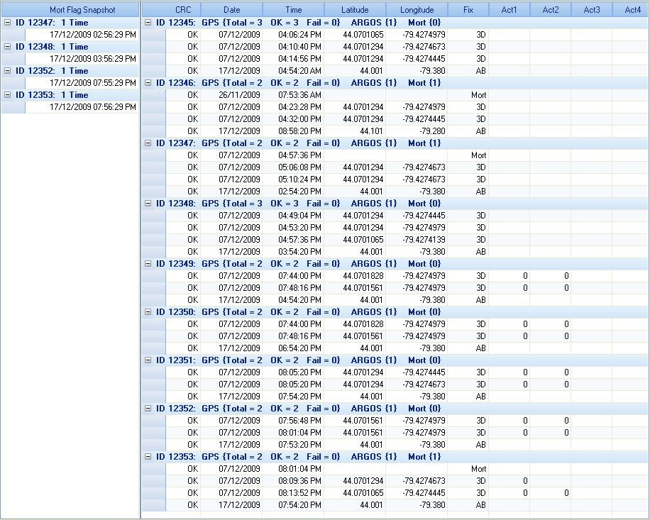

CRC Algorithms in C

unsigned char _PP_TableCrc8[256] = {0x00,0x07,0x0e,0x09,0x1c,0x1b,0x12,0x15,0x38,0x3f,0x36,0x31,0x24,0x23,0x2a,0x2d, 0x70,0x77,0x7e,0x79,0x6c,0x6b,0x62,0x65,0x48,0x4f,0x46,0x41,0x54,0x53,0x5a,0x5d, 0xe0,0xe7,0xee,0xe9,0xfc,0xfb,0xf2,0xf5,0xd8,0xdf,0xd6,0xd1,0xc4,0xc3,0xca,0xcd, 0x90,0x97,0x9e,0x99,0x8c,0x8b,0x82,0x85,0xa8,0xaf,0xa6,0xa1,0xb4,0xb3,0xba,0xbd, 0xc7,0xc0,0xc9,0xce,0xdb,0xdc,0xd5,0xd2,0xff,0xf8,0xf1,0xf6,0xe3,0xe4,0xed,0xea, 0xb7,0xb0,0xb9,0xbe,0xab,0xac,0xa5,0xa2,0x8f,0x88,0x81,0x86,0x93,0x94,0x9d,0x9a, 0x27,0x20,0x29,0x2e,0x3b,0x3c,0x35,0x32,0x1f,0x18,0x11,0x16,0x03,0x04,0x0d,0x0a, 0x57,0x50,0x59,0x5e,0x4b,0x4c,0x45,0x42,0x6f,0x68,0x61,0x66,0x73,0x74,0x7d,0x7a, 0x89,0x8e,0x87,0x80,0x95,0x92,0x9b,0x9c,0xb1,0xb6,0xbf,0xb8,0xad,0xaa,0xa3,0xa4, 0xf9,0xfe,0xf7,0xf0,0xe5,0xe2,0xeb,0xec,0xc1,0xc6,0xcf,0xc8,0xdd,0xda,0xd3,0xd4, 0x69,0x6e,0x67,0x60,0x75,0x72,0x7b,0x7c,0x51,0x56,0x5f,0x58,0x4d,0x4a,0x43,0x44, 0x19,0x1e,0x17,0x10,0x05,0x02,0x0b,0x0c,0x21,0x26,0x2f,0x28,0x3d,0x3a,0x33,0x34, 0x4e,0x49,0x40,0x47,0x52,0x55,0x5c,0x5b,0x76,0x71,0x78,0x7f,0x6a,0x6d,0x64,0x63, 0x3e,0x39,0x30,0x37,0x22,0x25,0x2c,0x2b,0x06,0x01,0x08,0x0f,0x1a,0x1d,0x14,0x13, 0xae,0xa9,0xa0,0xa7,0xb2,0xb5,0xbc,0xbb,0x96,0x91,0x98,0x9f,0x8a,0x8d,0x84,0x83, 0xde,0xd9,0xd0,0xd7,0xc2,0xc5,0xcc,0xcb,0xe6,0xe1,0xe8,0xef,0xfa,0xfd,0xf4,0xf3};

unsigned char CalcCrc8(const unsigned char *pData, int nCount)
{

unsigned char bCrc = 0;

for (int i = 0; i < nCount; i++)
{
bCrc ^= pData[i];

bCrc = _PP_TableCrc8[bCrc];
}

return bCrc;

}

